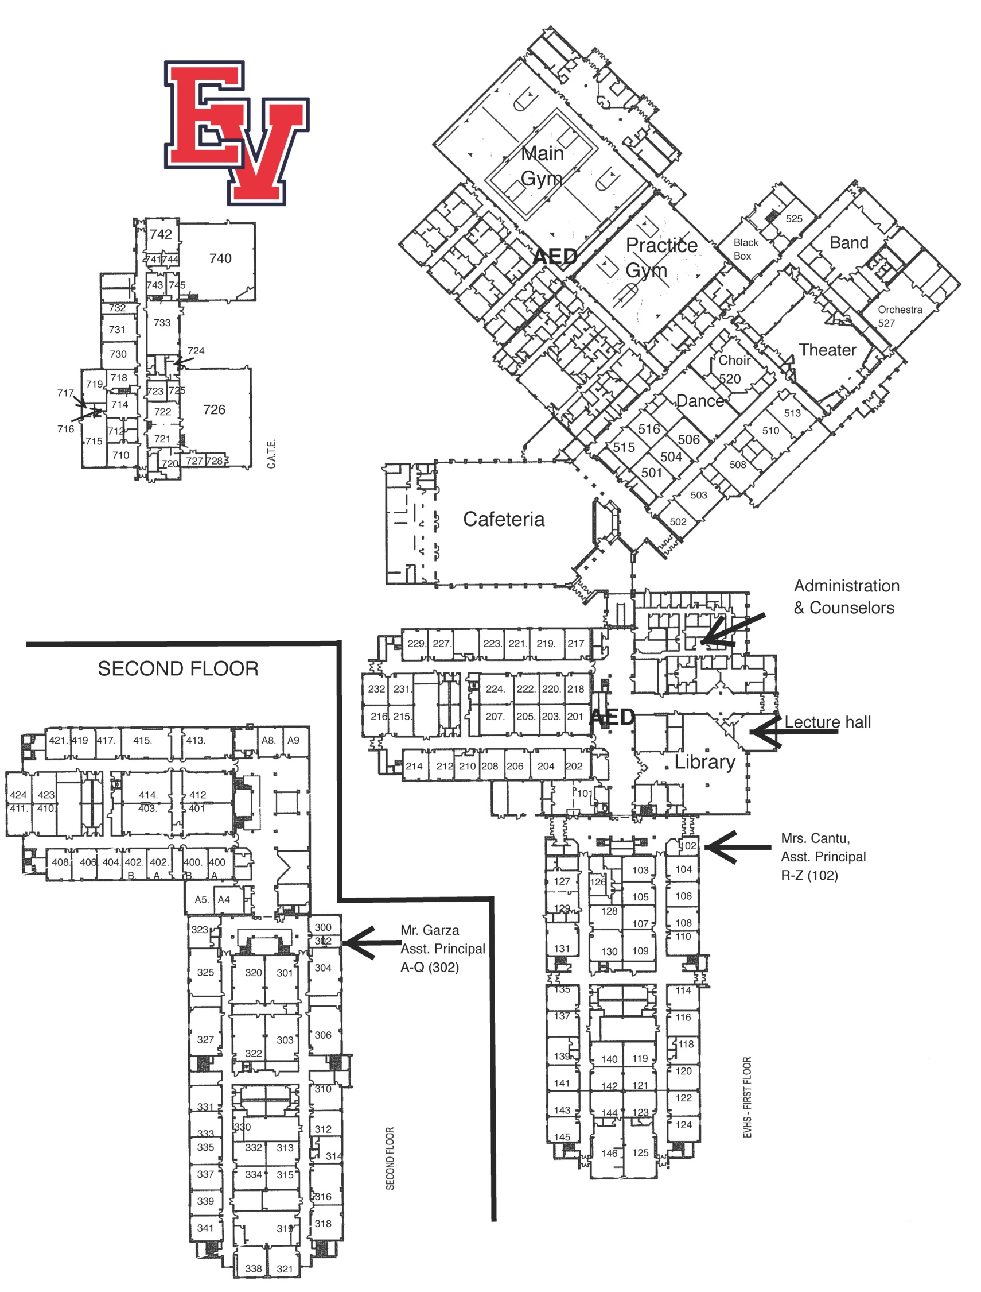

**Jr/Sr Quiz**

**Jr Conducting**

**Sr Conducting**

**Ag Advocacy**

**PR**

**Jr/Sr Creed**

**Ag Rooms 722-721 for Tabulation**

**Judges & Coaches Hospitality**

**Rear Entrance**

**Front Entrance**

**To CTE Bldg**

**Awards**

**Office**

**Sr Skills**

**Jr Skills**

**Ag Issues**

**Job Int**

**Radio**

**Holding Area**